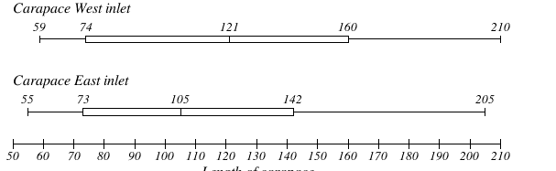
Context

Observations
- Known effect of pollution on particular crabs
- average size of species

Assumptions
- Same sex (All males / Females)
- similar food sources in each inlet

Mathematical Techniques
- Box plots
- Scatter plots
- Lines of best fit

# Results

# Discussion
Strengths and lims

Conclusion

